[](https://en.wikipedia.org/wiki/File:Doug_Dohring_at_Age_of_Learning_with_ABCmouse_sign.jpg)

The teacher guide with ABCmouse.app/com.bd with colors, alphabets, numbers and math, letters etc. With 300,000 Teachers at ABC Mouses

A B C D E F G H I J K L M N O P Q R S T U V W X Y Z

1 2 3 4

5 6 7 8

9 10 11

12 13 14

15 16 17

18 19 20

21 22 23

24 25 26

27 28 29

30 31 32

33 34 35

36 37 38

39 40 41

42 43 44

45 46 47

48 49 50

51 52 53

54 55 56

57 58 59

60 61 62

63 64 65

66 67 68

69 70 71

72 73 74

75 76 77

78 79 80

81 82 83

84 85 86

87 88 89

90 91 92

93 94 95

96 97 98

99 100

[](https://www.needpix.com/photo/download/1350868/alphabet-letters-alphabetletters-a-z-bright-colorful-clip-art-plain-plaincolors)

The Letters are 26 letters

[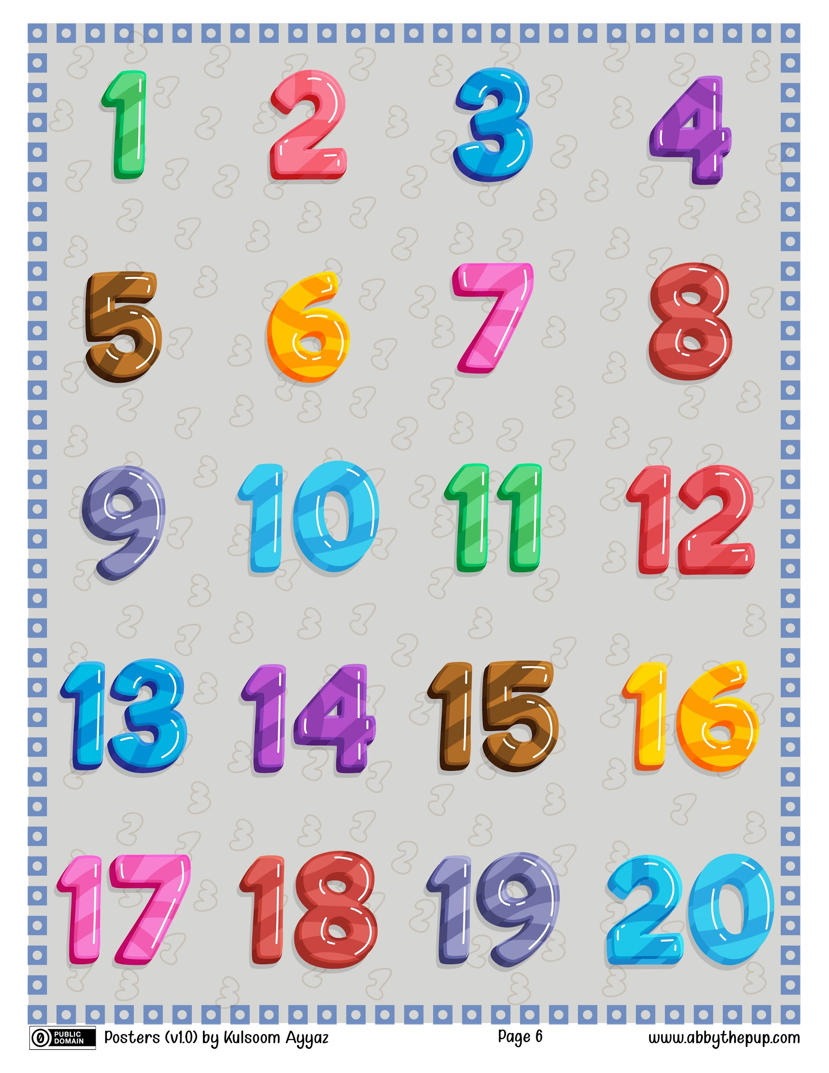](https://commons.wikimedia.org/wiki/File:Numbers_1-20_(Abby_the_Pup).jpg)

The Numbers from 20

Let’s Recap the word solving:

* 1
* 2
* 3
* 4
* 5
* 6
* Recap the ABCmouse of 300,000 words with dead number solving languages with Letter 596 words with Kindergarten also 39900 minutes with Recap Kindergarten also not all minutes also 5 minutes with recap words and writing with the word solvers colors
* The Solve creations it’s are the name of schools

The Recap with ABCmouses with recap of the school

Creation the word solving with solver

What is your father’s name?

______________________

What is your mother’s name?

_______________________

What is your grandma’s name?

________________________

[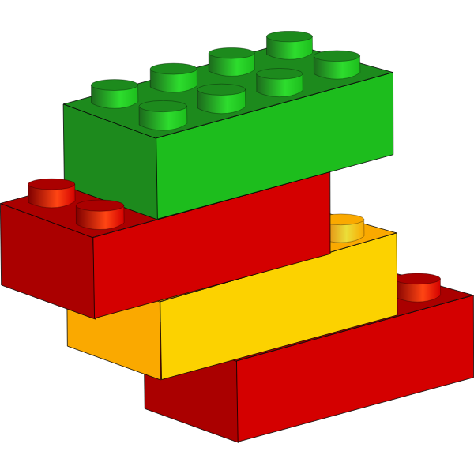](https://freesvg.org/vector-drawing-of-stackable-plastic-blocks)

Play with blocks

[](https://en.wikipedia.org/wiki/File:Doug_Dohring_at_Age_of_Learning_with_ABCmouse_sign.jpg)

Learning with teacher ABCmouse

[](https://commons.wikimedia.org/wiki/File:Noun_project_-_Music_notes.svg)

Listen some musics

[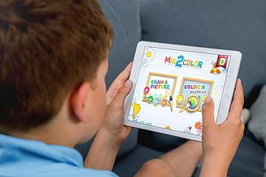](https://www.pxfuel.com/en/search?q=studying)

Play a games

[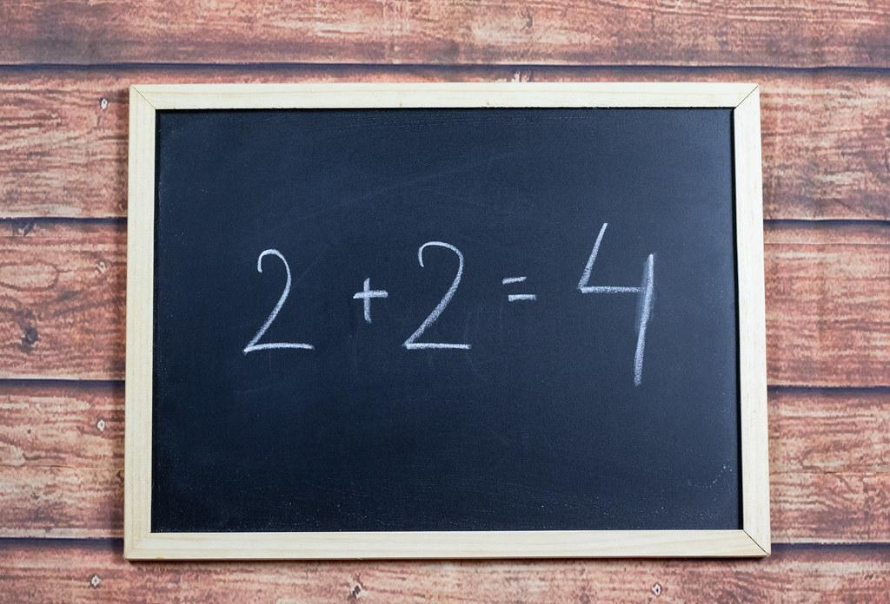](https://www.flickr.com/photos/91261194@N06/31294219367)

Learn some Maths

[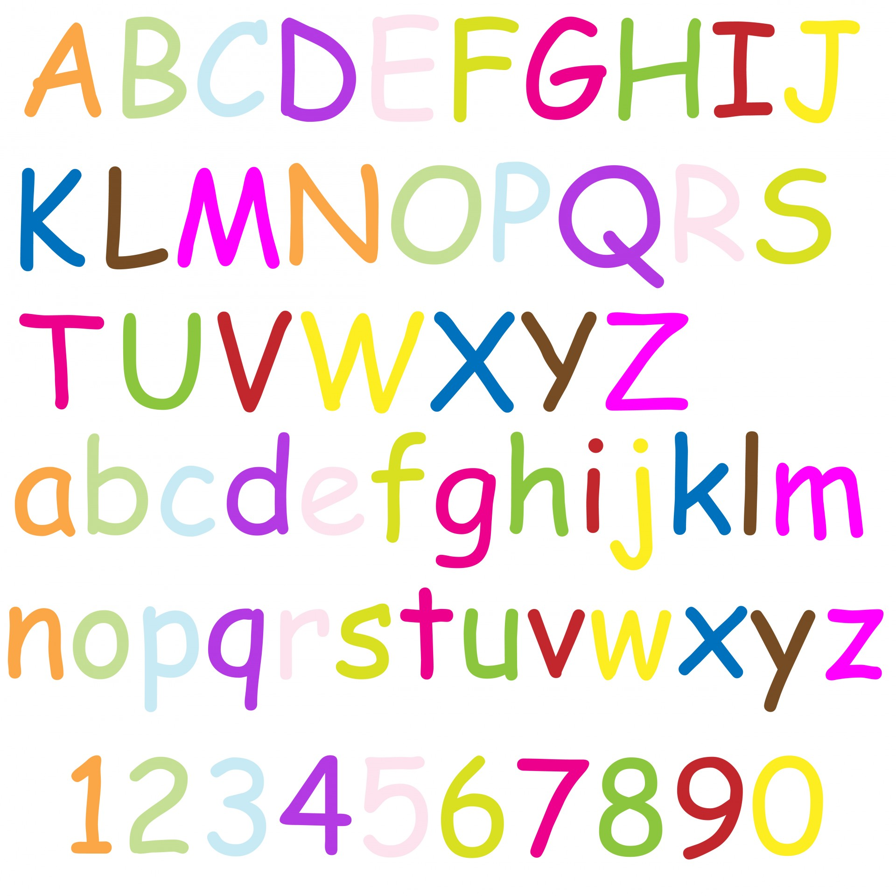](https://www.needpix.com/photo/1371959/alphabetletters-alphabet-a-z-numbers-handwritten-colorful-bright-text-illustration)

Learn some letters and numbers

Learning ABCmouse 1:

(He is new for friends, Jelle’s Family is happy for his new friend and he is so shy why are you so shy Amsl? I want to be friend with you stolen he go to another home, Where could Amsl go? Oh I see Amsl where he ran away again. Amsl where are you? Amsl is an girl she lives on Indonesia Home so we are Indonesia from 8 Lift. Indonesia is 8 Lift when 12 is at 8 we cannot tap 12! 12 Lift is Maghbia City we tap 8 and We tap 11 at Dhaka We tap 8 at Indonesia. Where could Amsl go? Amsl ran away from the stairs Oh My God!! Here are strangers he can catch and put in the bag where could Amsl go Amsl comed into my house where she? She is in chair at the bottom Oh no!!!!!!! Dad is angry but mom can help dad pushed but dad didn’t pushed anyway then we are safe now Oh my Friend Jelle tells “Don’t go Lost anywhere and Don’t go anywhere just follow with Jelle abnd Dad and Mom)

So what Jelle tells “ Don’t go anywhere just follow with Jelle and Dad and Mom” Always be Careful Jelle tells a story for his family and Jelle’s Family

After the story is fun,

The End!

The Graph sensitive at 5:30 PM the clock is graphing 80wea at the time at 9300wea pasts of 7:39:00 at the timer

1. Draw the minute hand andhour hand\

[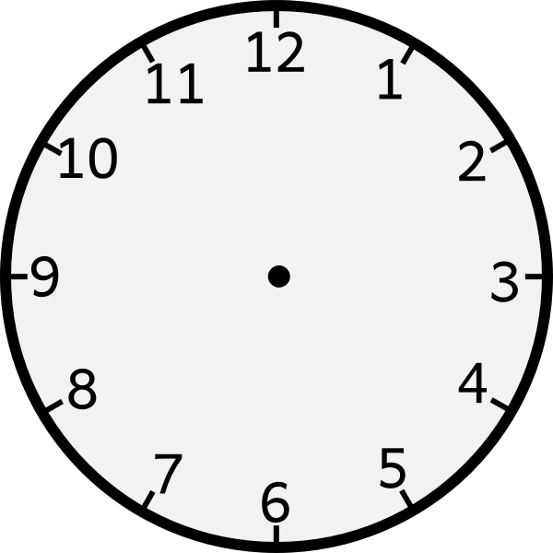](https://freesvg.org/vector-graphics-of-wall-clock-with-numbers)

7:00

[](https://freesvg.org/vector-graphics-of-wall-clock-with-numbers)

9:00

12:00

2:40

1:59

ABCmouse Description 2:

(The Graph OF 100,000 and 930 of full learnings with techer as grown with new learning with ABCmouse anyway you can tell me how it’s ABCmouses at graph? YEAH!)